**SPLUNK**





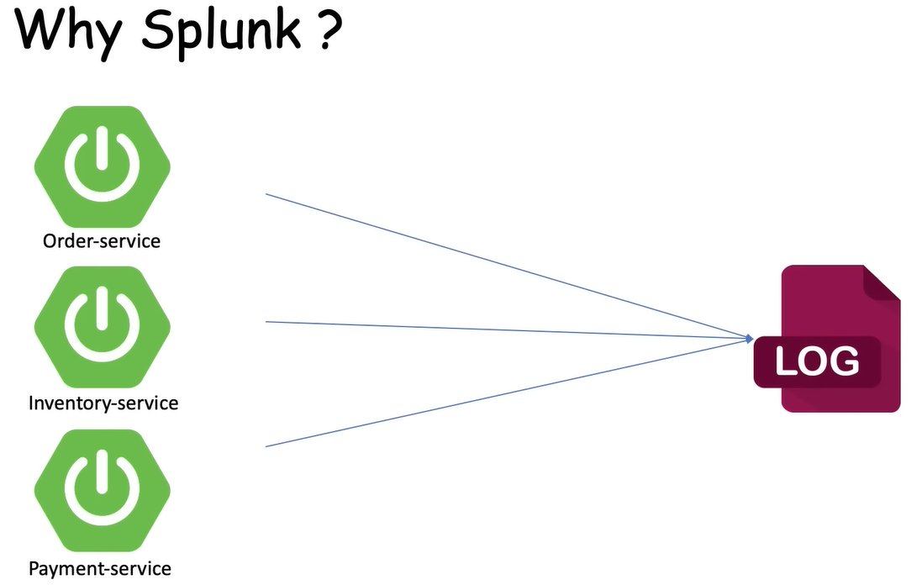

Suppose I am getting all services log in single log file which is showing in above and getting a problem in Payment-Service and then how to search and where problem is coming it’s very difficult so solving this problem **Splunk** come in picture.

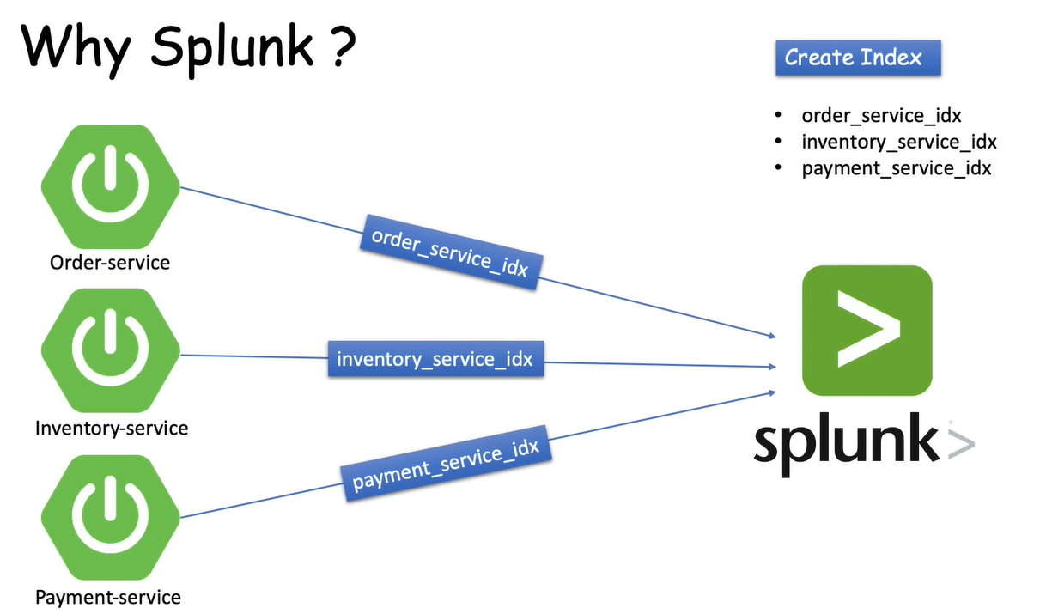

To solving above problem means store all logs in single log file to over come this problem splunk come into picture.

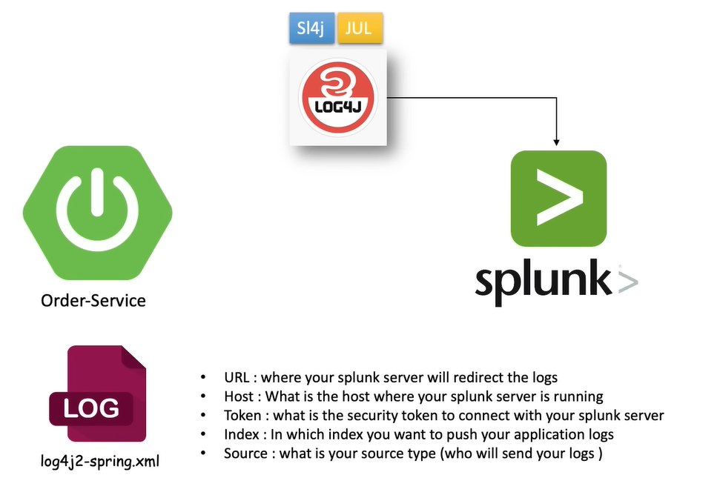

We are creating spring boot project like Order-Service and using Log4j framework or util framework for log, and then after capture the log of our application and then after forward to splunk like above.

**How to Create Splunk Account and How to install Splunk.**

Step-1,

Go to Google and type below,

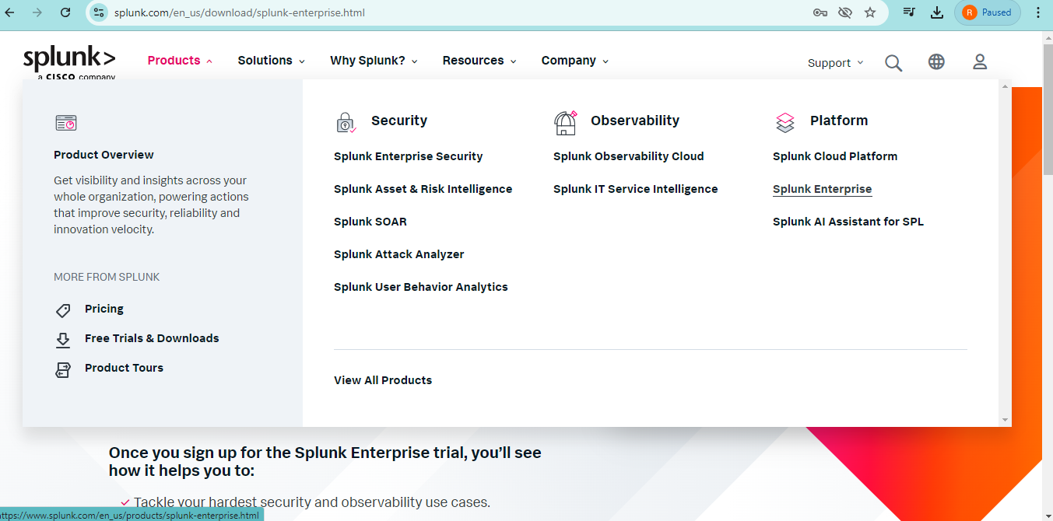

Step-2, Go to splunk Enterprise edition.

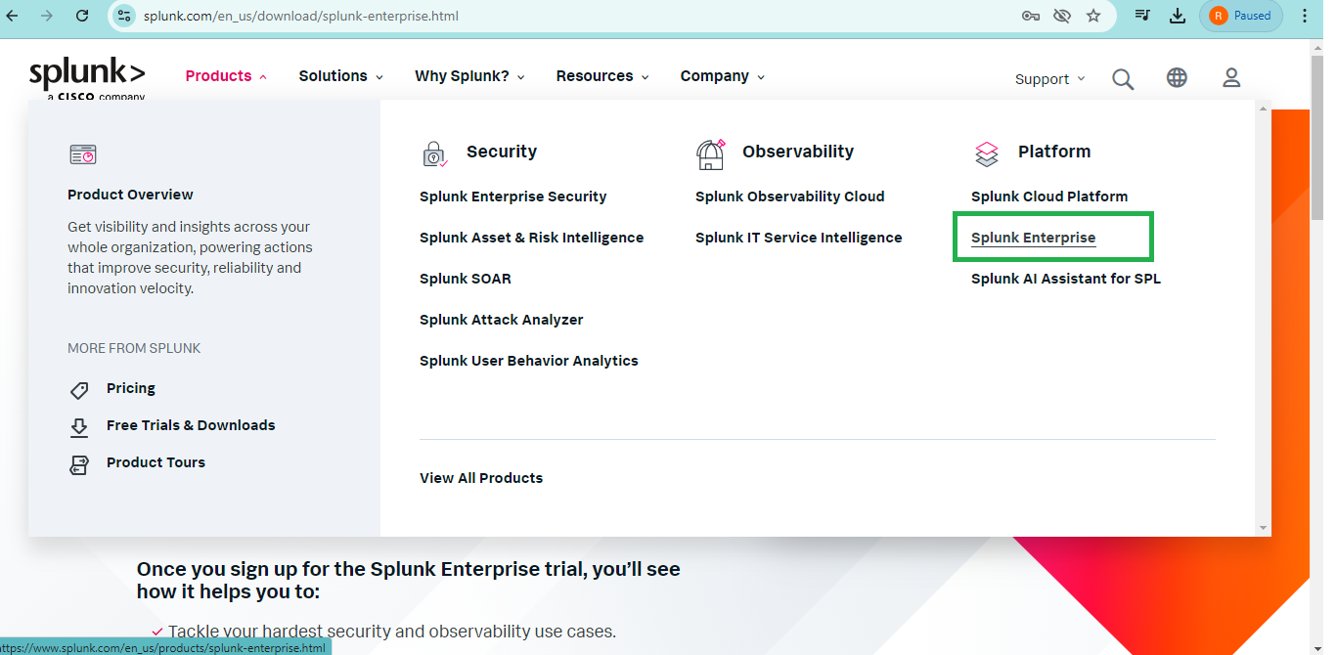

Step-3, then after go to Free Splunk.

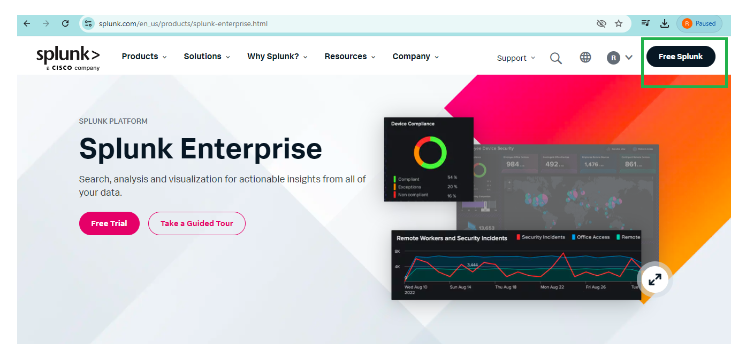

Step-4, field the details and create account.

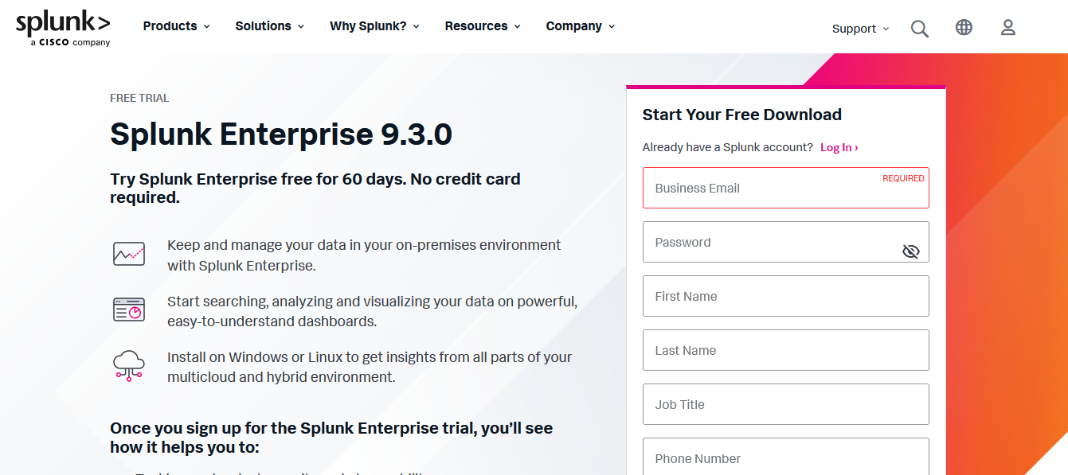

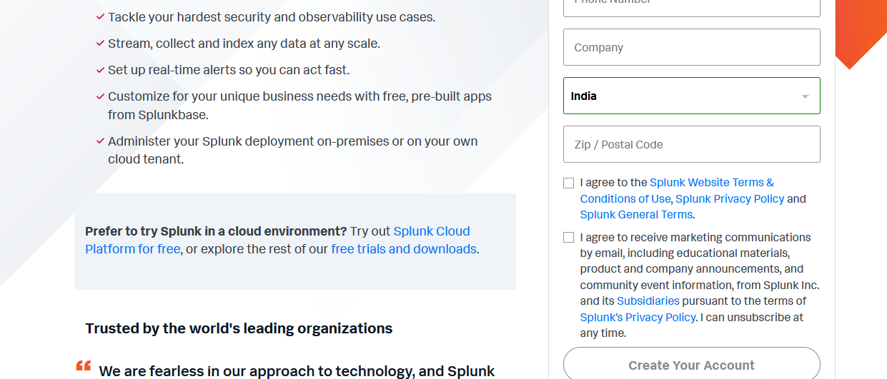

Step-5, after filing the form you can download the splunk setup file.

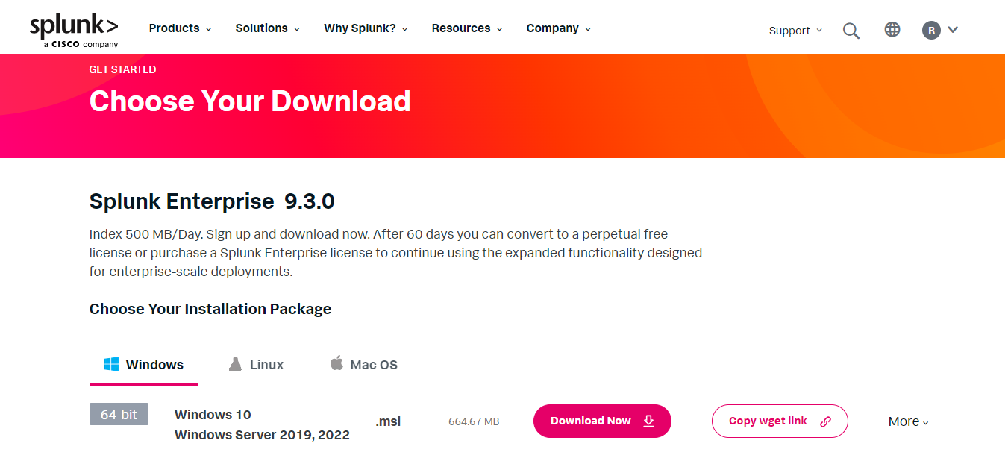

Step-6, After download it’s look like this.

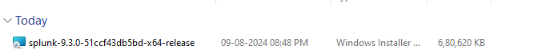

Step-7, Click on setup file it’s installed your machine.

**Configuration part Start from here**

Step-8, go to browser and open with it’s default port 8000 just like below.

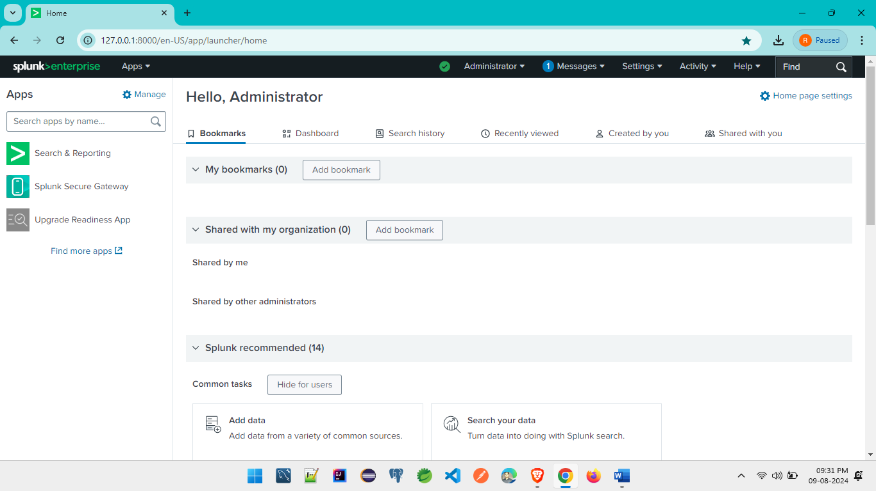

Step-9, click on step-2 Data inputs just like below.

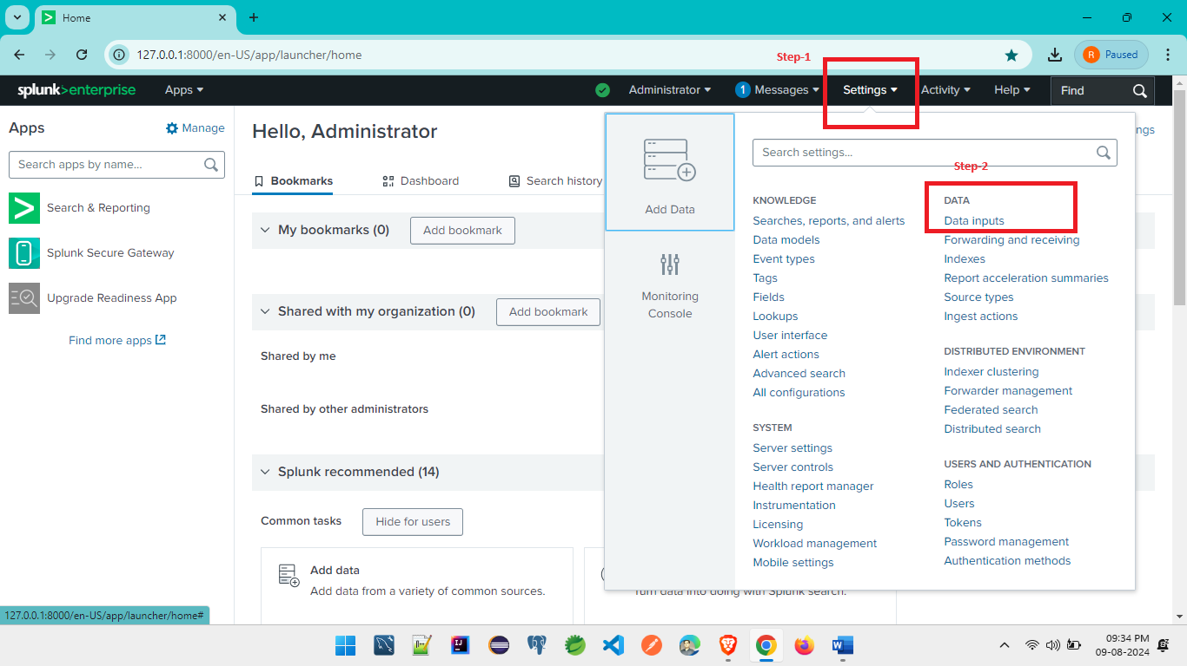

Step-10, After click Data Input it’s look like this.

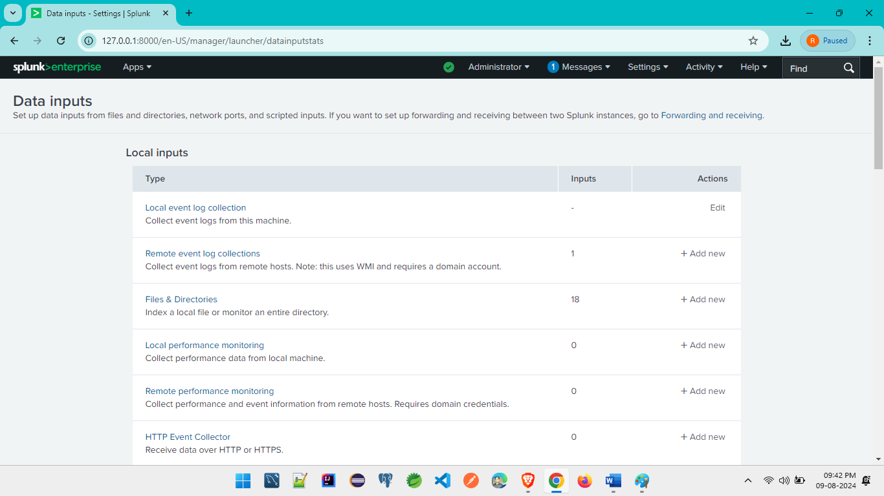

Step-11, go to below service which is showing in image.

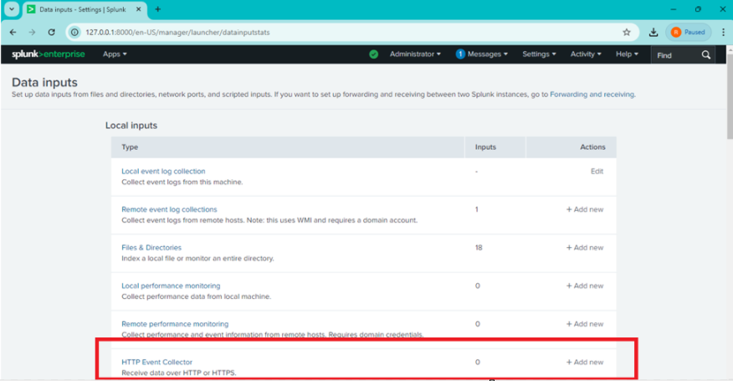

Step-12, After clicking the above service it’s look like this.

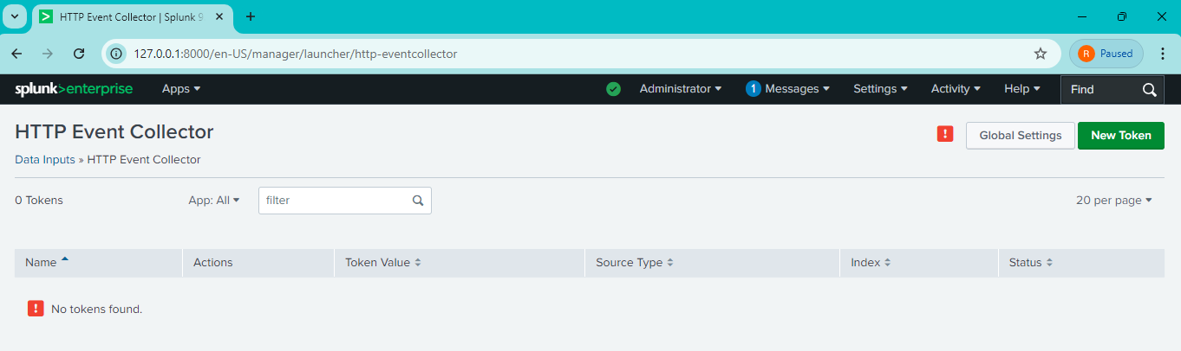

Step-13, Then after go to below tag means Global Setting.

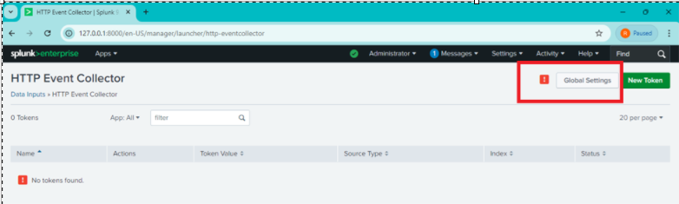

Step-14, After clicking Global Setting it’s look like this and remember **Http Port Number** and then after **save** it.

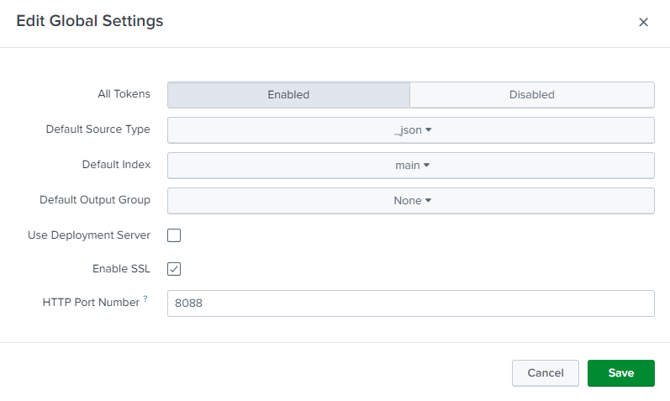

Step-15, After **save**, go to below page and Click on **New Token** just like below.

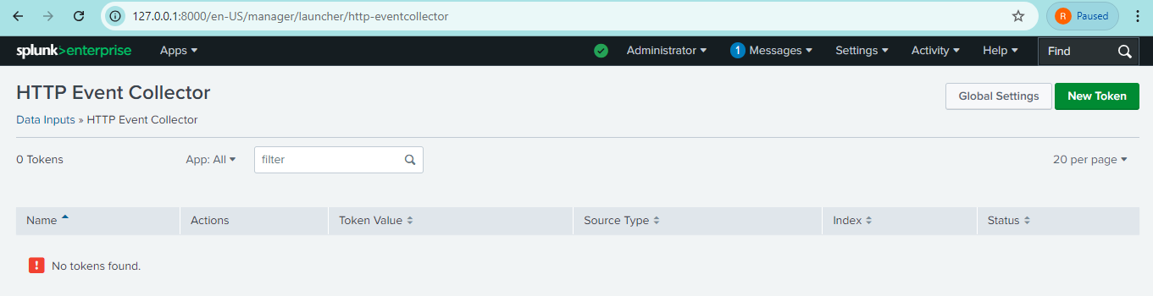

Step-16, After clicking, **New Token** it’s look like below and field the details according your applications.

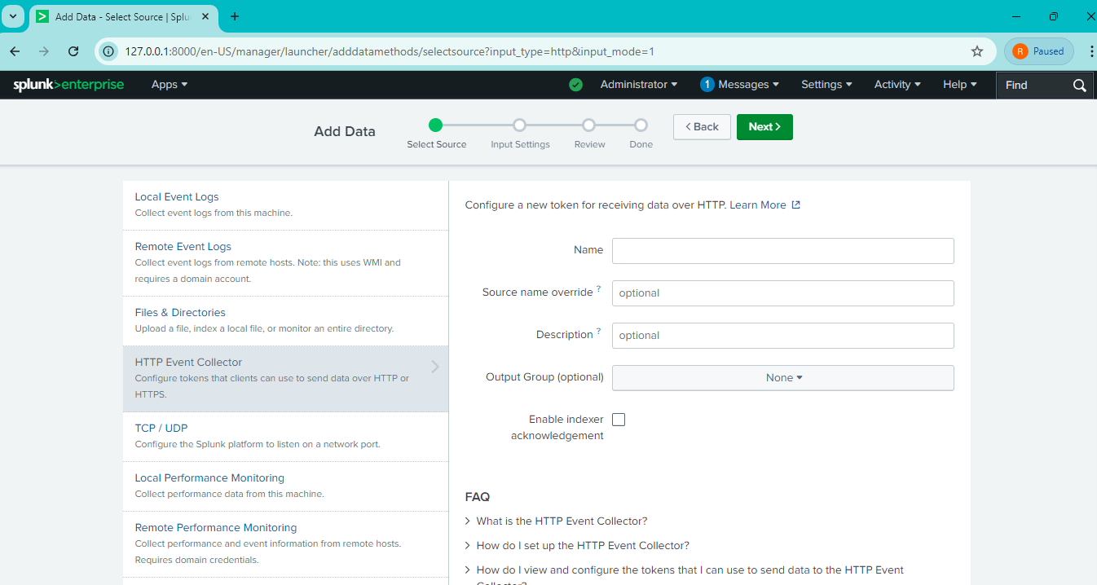

Step-17, after field the details according our application it’s look like this.

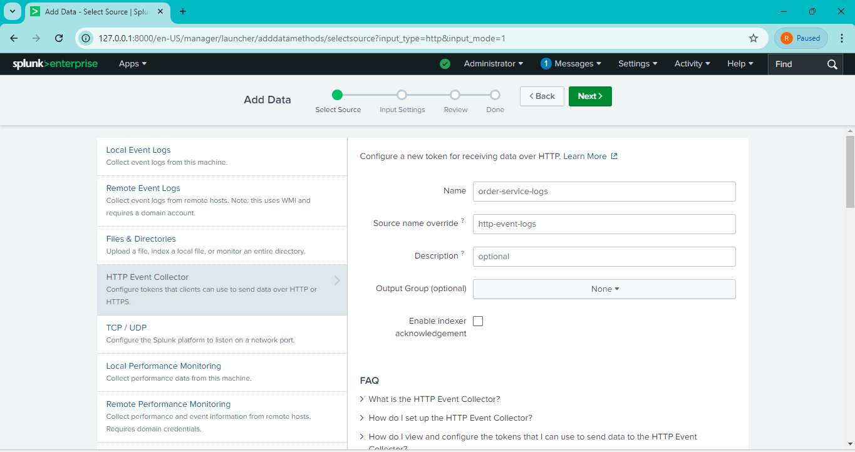

Step-18, After filing the details and clicked **Next** and it’s look like below.

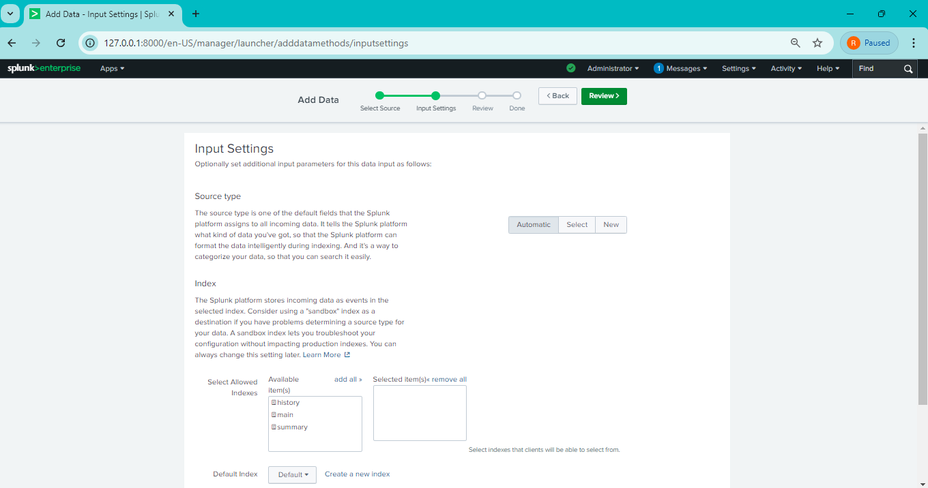

Step-19, After clicking the **Next** it’s showing below and filled details look like this.

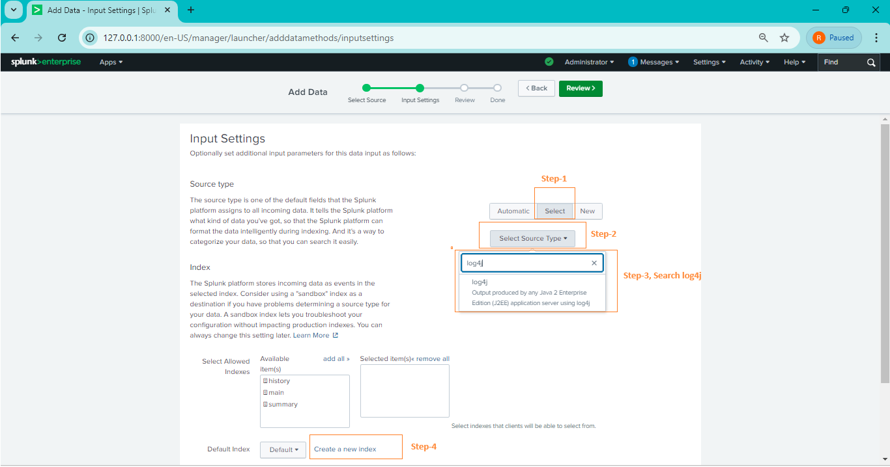

Step-20, After clicking the Step-4 in above image and it’s look like this.

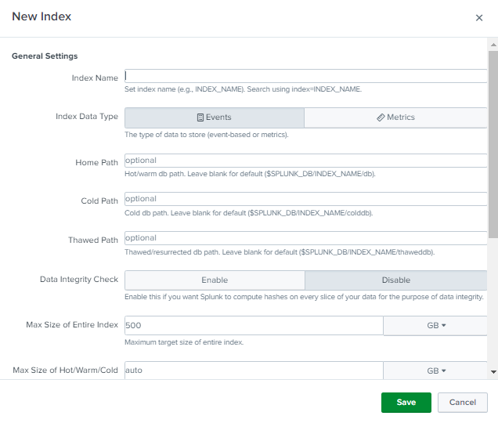

Step-21, After providing the **Index Name** and click **save.**

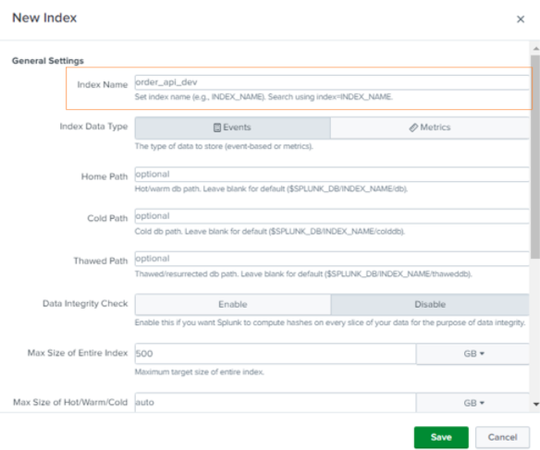

Step-22, After **save** the above tag and it’s looks like below and then select which api you have created just like below image.

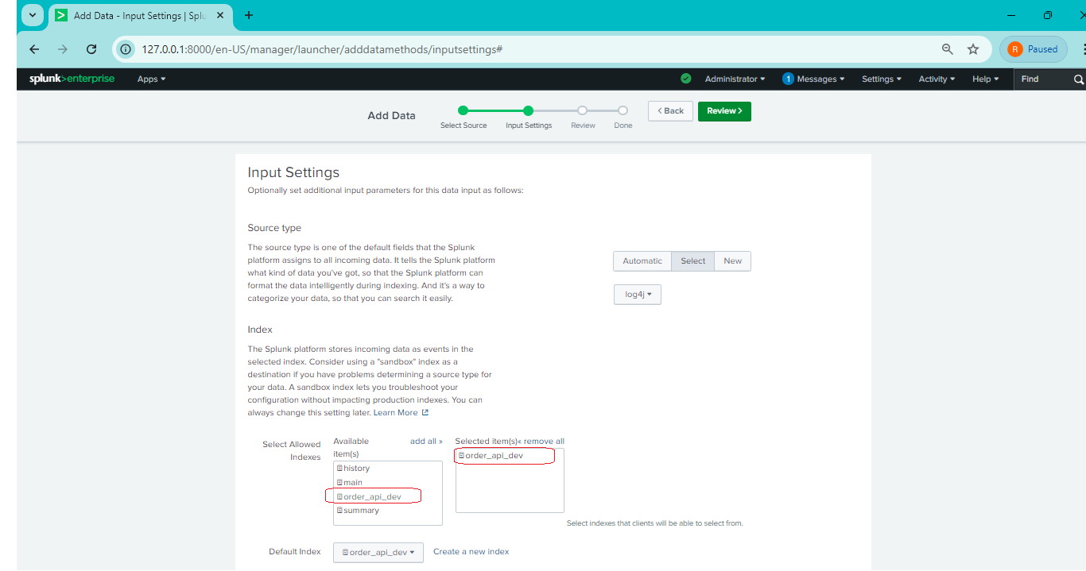

Step-23,

After selecting above api which you are created and then after click **Review Tag**.

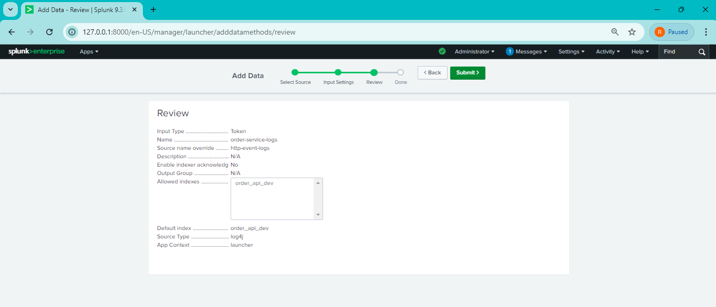

Step-24, After **Review Tag** and Then After click **Submit Tag** and it’s look like this.

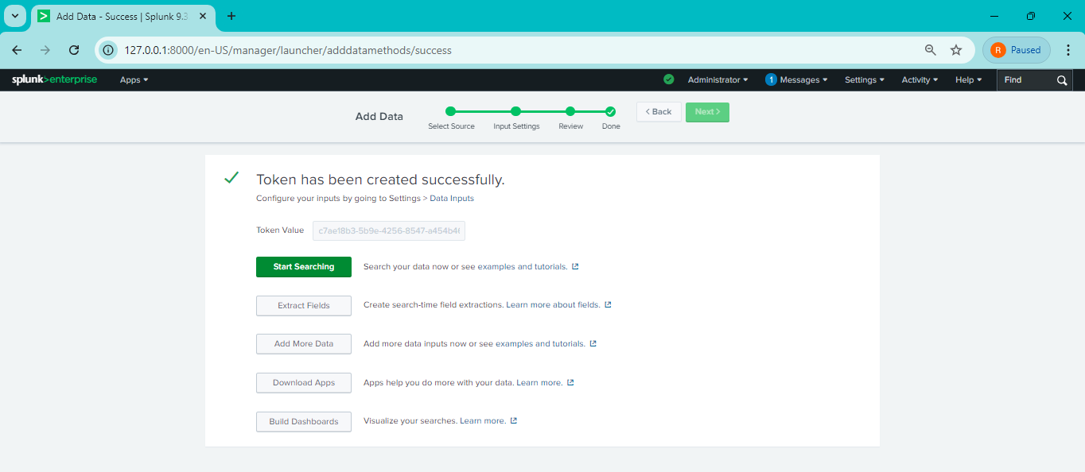

Step-25, After **Submit Tag**, again go to **Setting tag** and again go to **Data Input** Tag just like below.

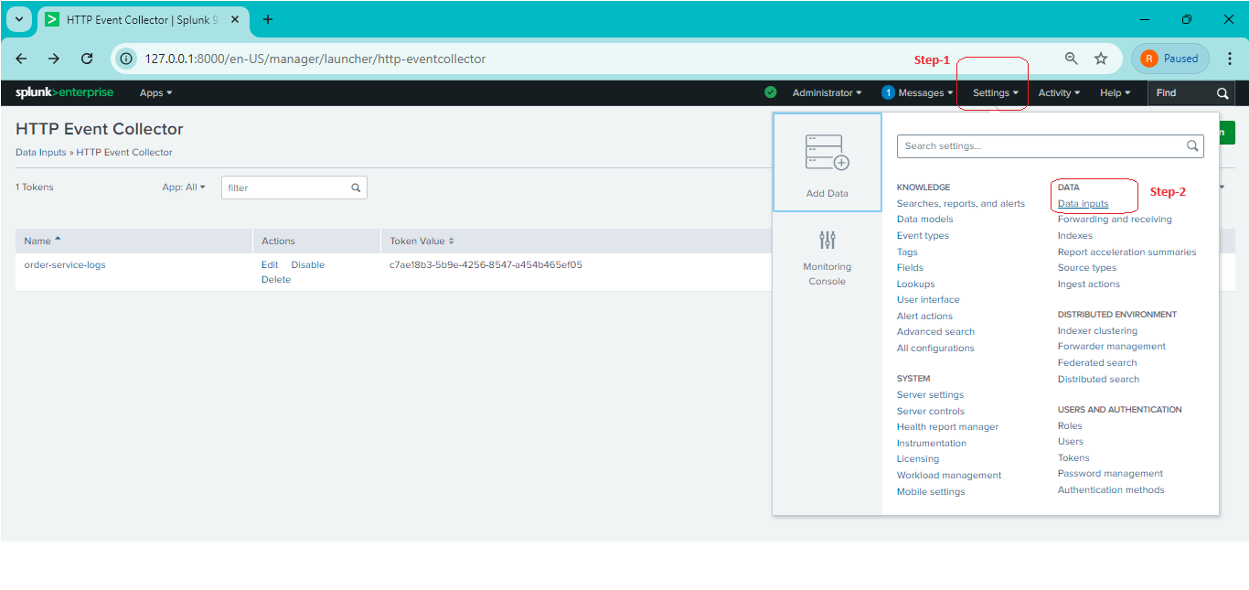

Step-26, After click **Data Input** tag, it’s showing like below and select just below.

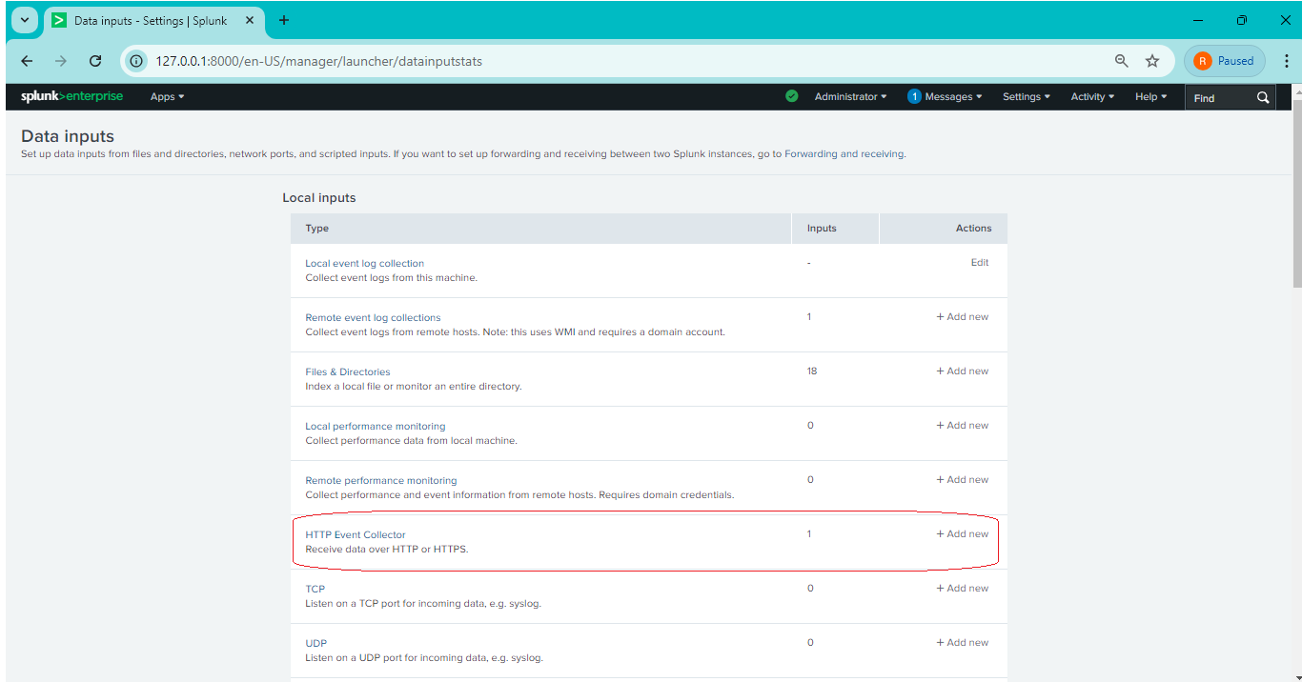

Step-27, After click **Http Event Collector tag**, it’s showing look like this.

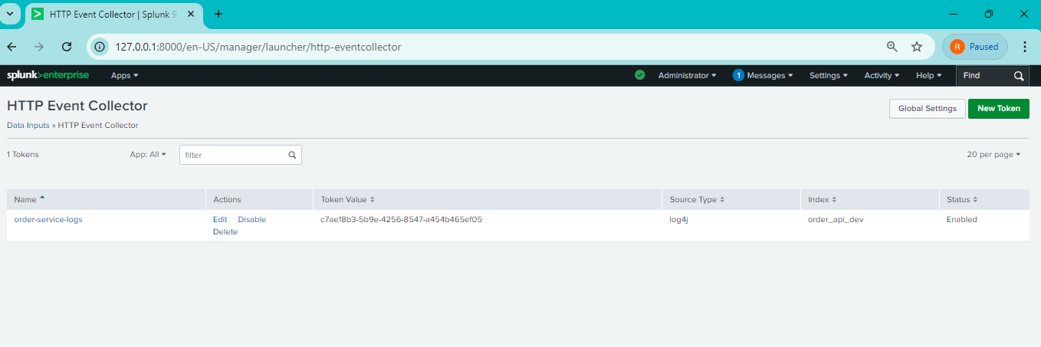

Step-28, Add splunk <repositories> tag .

1.

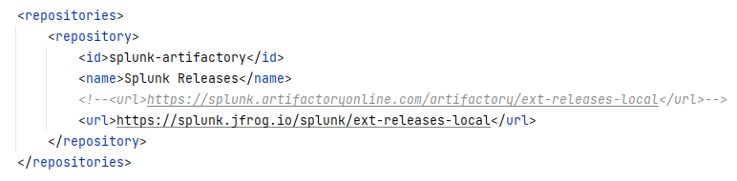

2.

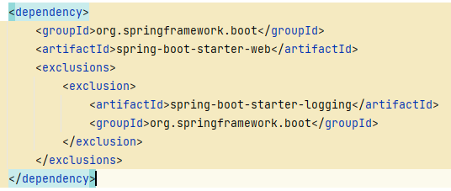

3.

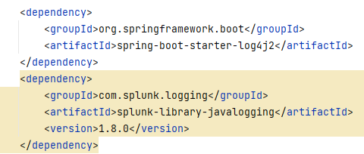

Step-29,

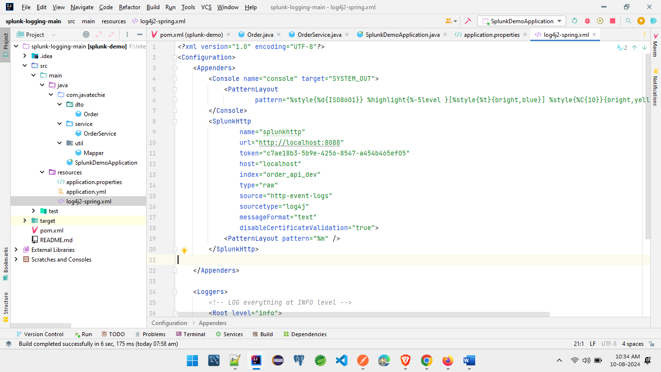

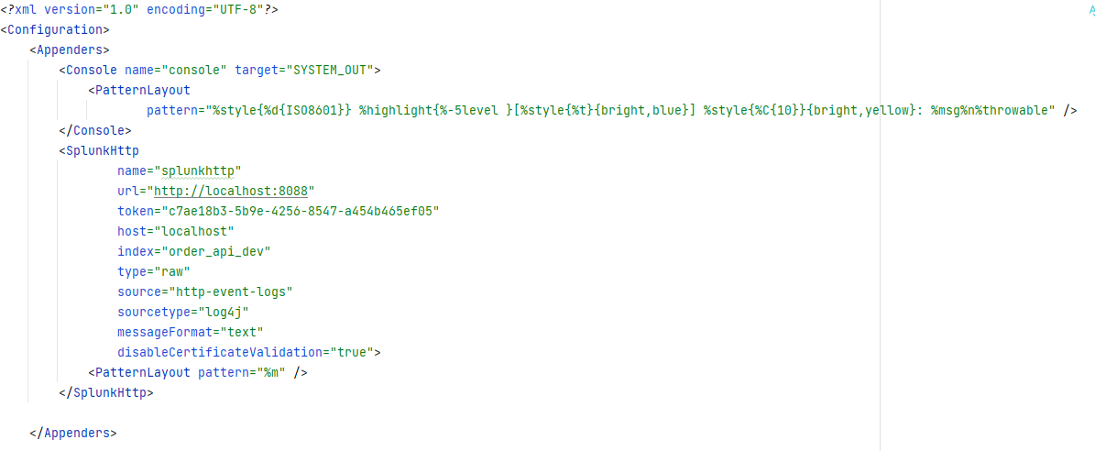

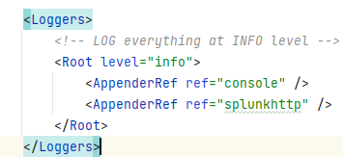

Step-30, add loger in class and methods like below.



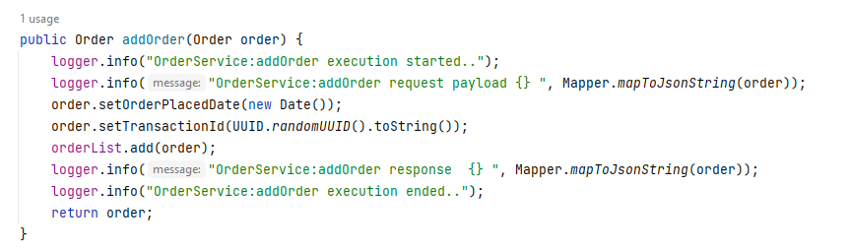

Step-31,

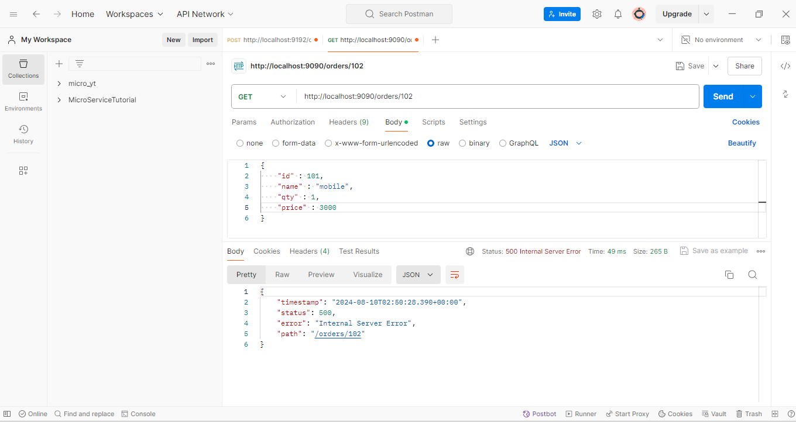

Step-32,

